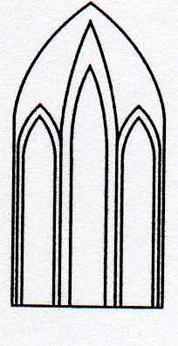
Catedral Anglicana St Paul´s
Valparaíso
Música en las Alturas
Organista: Christian Sundt
Domingo 30 de Diciembre, 2018
12:30 Horas
Entrada liberada

1-Ave verum corpus ..... W.A. Mozart(1756-1791)

2-O come all ye faithful.... John F. Wade(1711-1786)

3-Oh holy night...... A. Adams (1803-1856)

4-Liberty bell march J. P. Sousa (1854-1932)

5-Morning mood.... E. Grieg(1843-1907)

6-Angels we have heard on high........French carol

7-Dance of sugar plum fairy ......P. Tchaikovsky (1840-1893)

8-Joy to the world......... G. F. Handel
(1685-1759)

Agradecemos su contribución para la restauración de nuestro monumento histórico construido en 1858.
We are grateful for your contribution towards the restoration of this historic building built in 1858.
__________________________________________
saintpaulchurchvalpo@gmail.com
www.saintpaulchile.cl
https://facebook.com músicaenlasalturasvalparaíso
Twitter @IglesiaStPaul

