11 – 11 - 1918 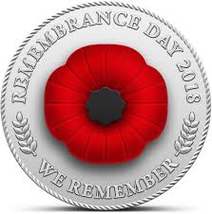 11 – 11 – 2018

The Restoration Committee of St Paul’s Cathedral has the pleasure

of inviting you to the ceremony commemorating 100 years of the

end of World War I. The ceremony will take place at 10.30 a.m. in

the Cathedral.

Pilcomayo 566, Cerro Concepción

